AGL Extractor Issues

EME Extractors
In EME Pages(which gets the number of pages) and Listing(which gets the listing urls on each page) extractors, we fixed the retailer which was selecting “None/Not Sure” to select AGL.
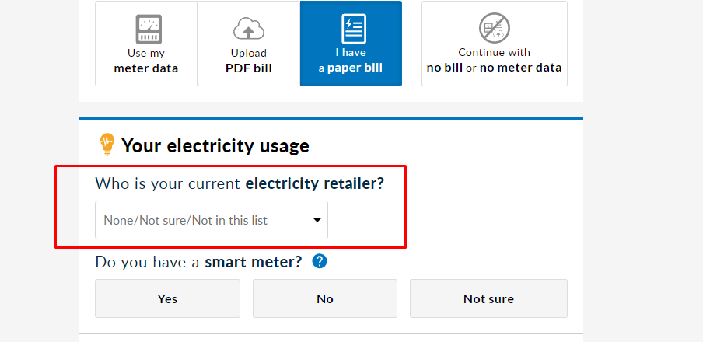
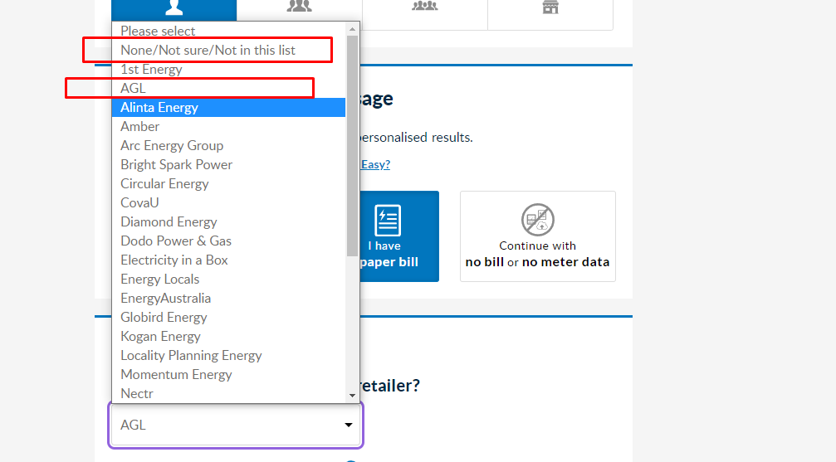

In Details extractors(which gets Details data from listing URL), we were getting missing data for a few attributes which were present on the website.

Extractors | Issues | Fix
EME-Case1-Elec-Resi-Pages | Retailer: None/Not Sure | Selecting Retailer as AGL
EME-Case1-Elec-Resi-Listing | Retailer: None/Not Sure | Selecting Retailer as AGL
EME-Case1-Elec-Resi-details | Missing Data | Fixed data for Green(y/n/o), Green Note and ETF
EME-Case1-Elec-Bui-Pages | Retailer: None/Not Sure | Selecting Retailer as AGL
EME-Case1-Elec-Bui-Listing | Retailer: None/Not Sure | Selecting Retailer as AGL
EME-Case1-Elec-Bui-Details | Missing Data | Fixed data for Green(y/n/o), Green Note and ETF
EME-Case1-Gas-Resi-Pages | Retailer: None/Not Sure | Selecting Retailer as AGL
EME-Case1-Gas-Resi-Listing | Retailer: None/Not Sure | Selecting Retailer as AGL
EME-Case1-Gas-Resi-Details | Missing Data | Fixed data for ETF
EME-Case1-Gas-Bui-Pages | Retailer: None/Not Sure | Selecting Retailer as AGL
EME-Case1-Gas-Bui-Listing | Retailer: None/Not Sure | Selecting Retailer as AGL
EME-Case1-Gas-Bui-Details | Missing Data | Fixed data for ETF and gasHeater
EME-Case2-Elec-Resi-Listing | No issue
EME-Case2-Elec-Resi-Pages | Retailer: None/Not Sure | Selecting Retailer as AGL
EME-Case2-Elec-Busi-Listing | No issue
EME-Case2-Elec-Busi-Pages | Retailer: None/Not Sure | Selecting Retailer as AGL
EME-Case2-Gas-Resi-Listing | Missing Data | Fixed data for Plan Name, Annual Bill Without Discount
EME-Case2-Gas-Resi-Pages | Retailer: None/Not Sure | Selecting Retailer as AGL
EME-Case2-Gas-Busi-Listing | Missing Data | Fixed data for Annual Bill Without Discount
EME-Case2-Gas-Resi-Pages | Retailer: None/Not Sure | Selecting Retailer as AGL

VIC Gas Extractors

All VIC Gas extractors were fixed from scratch due to changes in the website. Later they started failing due to a few selector issues. Updating those selectors fixed the extractor.

Extractors | Issues | Fix
VIC-Case1-Gas-Resi | Selector Issues | Updated the selectors
VIC-Case1-Gas-Resi-1 | Selector Issues | Updated the selectors
VIC-Case1-Gas-Resi-2 | Selector Issues | Updated the selectors
VIC-Case1-Gas-Busi | Selector Issues | Updated the selectors
VIC-Case1-Gas-Busi-1 | Selector Issues | Updated the selectors
VIC-Case1-Gas-Busi-2 | Selector Issues | Updated the selectors
VIC-Case2-Gas-Resi-Ranking | Selector Issues | Updated the selectors
VIC-Case2-Gas-Busi-Ranking | Selector Issues | Updated the selectors

VIC Electricity Extractors

Extractors | Issues
VIC-Case1-Elec-Resi-Detail | File Upload and Recaptcha
VIC-Case1-Elec-Resi-Detail-1 | File Upload and Recaptcha
VIC-Case1-Elec-Resi-Detail-2 | File Upload and Recaptcha
VIC-Case1-Elec-Busi-Detail | File Upload and Recaptcha
VIC-Case1-Elec-Busi-Details1 | File Upload and Recaptcha
VIC-Case1-Elec-Busi-Details2 | File Upload and Recaptcha
VIC-Case2-Elec-Resi-Ranking | File Upload and Recaptcha
VIC-Case2-Elec-Busi-Ranking | File Upload and Recaptcha

Issues

- File Upload Issue

Since the extractors were failing for a long time, there was a change in website structure. The code and APIs that were used for file upload earlier were not working.

- Captcha Issue

After the file upload issue got resolved. The websites are protected by Invisible reCaptcha. We were having issues resolving the captcha using import APIs “solveCaptcha” functions.

What did we do to fix the issue?

The extractor was updated upto file upload and was sent to the L3 engineering team. They came back with proper APIs and code for file upload and getting the data. The APIs were working fine on the website in the browser but when we tried the same in the extractor, we were getting “Invalid reCaptcha” in the response.

We tried using Captcha functions to resolve captcha. We also tried removing the Captcha element from the website but then we were unable to make the API calls since we need a recaptcha response in the API.

The recaptcha issue was then escalated to L3. And then to L4. From L4, we got suggestions to resolve the issues.

How did we fix it?

File Upload and Getting Data

We have uploaded the data to a git repository. So, we are getting that data using an API from github and then using another API to upload the data on the website

API for getting data from github repo.

fetch('https://raw.githubusercontent.com/ayushImport/testcsv/master/BUSI/' + filename);

API to upload data on the website.

fetch('https://compare.energy.vic.gov.au/api/upload-consumption-file', {
method: 'POST',
body: formData,
mode: "cors",
credentials: "include",
referrer: "https://compare.energy.vic.gov.au/",
referrerPolicy: "strict-origin-when-cross-origin",
headers: {
"accept": "application/json, text/plain, */*",
"accept-language": "en-US,en;q=0.9",
"sec-ch-ua": "\"Chromium\";v=\"104\", \" Not A;Brand\";v=\"99\", \"Google Chrome\";v=\"104\"",
"sec-ch-ua-mobile": "?0",
"sec-ch-ua-platform": "\"Windows\"",
"sec-fetch-dest": "empty",
"sec-fetch-mode": "cors",
"sec-fetch-site": "same-origin"
}

In the body, we are giving these parameters:

var formData = new FormData(document.forms['welcome_form']);
formData.delete('fileupload');
formData.append('energyType', 'Electricity');
formData.append('serverCacheId', document.querySelector('#PSBForm > input[type=hidden][name="session_id"]').value)
formData.append('recaptchaResponse', document.querySelector("#g-recaptcha-response-100000").value);
formData.append('consumptionFile', file);
formData.append('loopBack', false);
formData.append('fileName', 'file.csv');

After uploading the file to the website we were not getting any changes on the website to proceed further, so, we are using API to save the data to the server and get the offers.

For saving data to the server, we are using this:

// Saving data to server
let body = `{"showSolarSelection":false,"energyType":"Electricity","userType":"Small business","bill":"","twelveMonths":"1","retailer":2,"retailerName":"AGL","postcode":"${paramsObj.POSTCODE}","usageProfile":"2","averageDailyConsumption":${averageDailyConsumption},"nmi":"","skipNMI":false,"smartMeter":"1","fileProvider":2,"file":"file.csv","agree":"","disclaimer":true,"hasSolar":"0","solarCapacity":"","hasConcession":"0","feedInTariff":"","serverCacheId":"${serverCacheId}","distributor":${distributor},"distributorDerived":0,"recaptchaResponse":"03ANYolquc2ws0sV7puVoF-V8sIrL70yeb0MLSfAy-wXwEvCKEsv5VqYXN8Y45MBJiVUZ_7vGUlUo2o6KYaMSt-3IQ5HlRIs2qx4PKBDzMwRkd7IjLrtfNFCT79rgrj_LRN354r_GQKVlVP40--TNhn9GrsmVn8CQV4nwpDZXbtU1TczaxQD_sqfCmUELrRPj1hhUYWzO8FwZo3zmaKjRO5UfptI_BKajrjiXBcpIEBbuVRIIK_hIYqFRFBsBOMUA--nSF4tGzNTLCMre3fRRdFUmp8LURnOCGsT3XyG46Y3lqZOGq8ijEq01Up-80ku4x7JT4ChRY7Ivbi2YaMOwjFPTgmvZjrbgwfS5EPf9syw4QqGQMsG7_G0sZu3gHGo5CFvLD5jaZHWLW6jYKzktFFgvIddokPooz8mYAXpHGCOKlvIf-Zx1matPie2wg7m-LS6CzTmtVgk9VUpkb9RFW4ZW-MmsSym9FWjRWIq51bPBEJR9C8OIlGNtVEfb4N1NEbiwFkOjmNDjULUC9GaHWWKEHH7rL7GzxqvAEUMlpUoTFMw1ETcT6QRoZwWJgtAuf2iSH1eqTXSLvzsnGUfTmUe1ZlTyGinIXMQ","fileName":"file.csv","distributorSubmit":false,"pageDataType":"energyConfigData","loopBack":false}`
// console.log("Saving Body", body)
let savingResponse = await fetch("https://compare.energy.vic.gov.au/api/save-form-data", {
"headers": {
"accept": "application/json, text/plain, */*",
"accept-language": "en-US,en;q=0.5",
"content-type": "application/json",
"sec-fetch-dest": "empty",
"sec-fetch-mode": "cors",
"sec-fetch-site": "same-origin",
"sec-gpc": "1"
},
"referrer": "https://compare.energy.vic.gov.au/",
"referrerPolicy": "strict-origin-when-cross-origin",
"body": body,
"method": "POST",
"mode": "cors",
"credentials": "include"
});

And finally we are getting the offers using API:
let getdataAPI = `https://compare.energy.vic.gov.au/api/get-offers?serverCacheId=${serverCacheId}&loopBack=false&selectedEnergy=/offers`
// console.log("getDataAPI", getdataAPI)
let dataResponse = await fetch(getdataAPI, {
"headers": {
"accept": "application/json, text/plain, */*",
"accept-language": "en-US,en;q=0.9",
"sec-ch-ua": "\"Chromium\";v=\"104\", \" Not A;Brand\";v=\"99\", \"Google Chrome\";v=\"104\"",
"sec-ch-ua-mobile": "?0",
"sec-ch-ua-platform": "\"Windows\"",
"sec-fetch-dest": "empty",
"sec-fetch-mode": "cors",
"sec-fetch-site": "same-origin"
},
"referrer": "https://compare.energy.vic.gov.au/offers",
"referrerPolicy": "strict-origin-when-cross-origin",
"body": null,
"method": "GET",
"mode": "cors",
"credentials": "include"
});

let data = await dataResponse.json()

Captcha Issue

For captcha solving, We moved all the SAAS interactions in a single code Action. And we used the following code which clicks on the frame element blocked in the debugger.
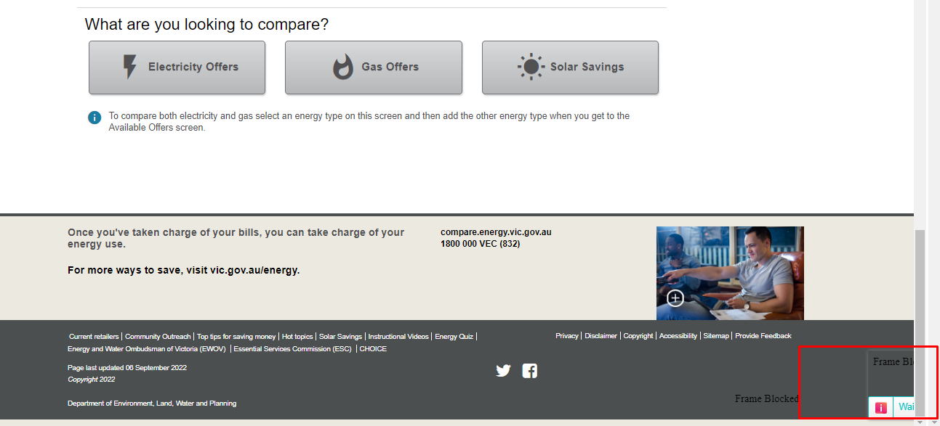

//Clicking on Import Captcha
await extractorContext.execute(async () => {
let captchaBtn = document.querySelector('div[class="captcha-solver-info"]')
if (captchaBtn) {
captchaBtn.click()
}
await new Promise((resolve) => { setTimeout(resolve, 20000) })
})

Current Status and ETA
All the VIC Electricity extractors have been fixed. And, one round of QA has been done. The QA raised the issue regarding missing data for few attributes. Those issues have also been fixed.

The extractors will be re-QAed and will be deployed to production by 8th September 2022.

