  - MOC and PSSR
1. Employee raising the MOC
Creating a draft - navigating to Grid, which shouldn't be. Should stay in the form page
Save as draft -> keep on same page (both MOC and PSSR) [Aditya]
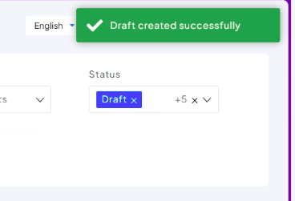
Not showing the status in the draft field page, but in the grid it is showing as draft [Dhruv]
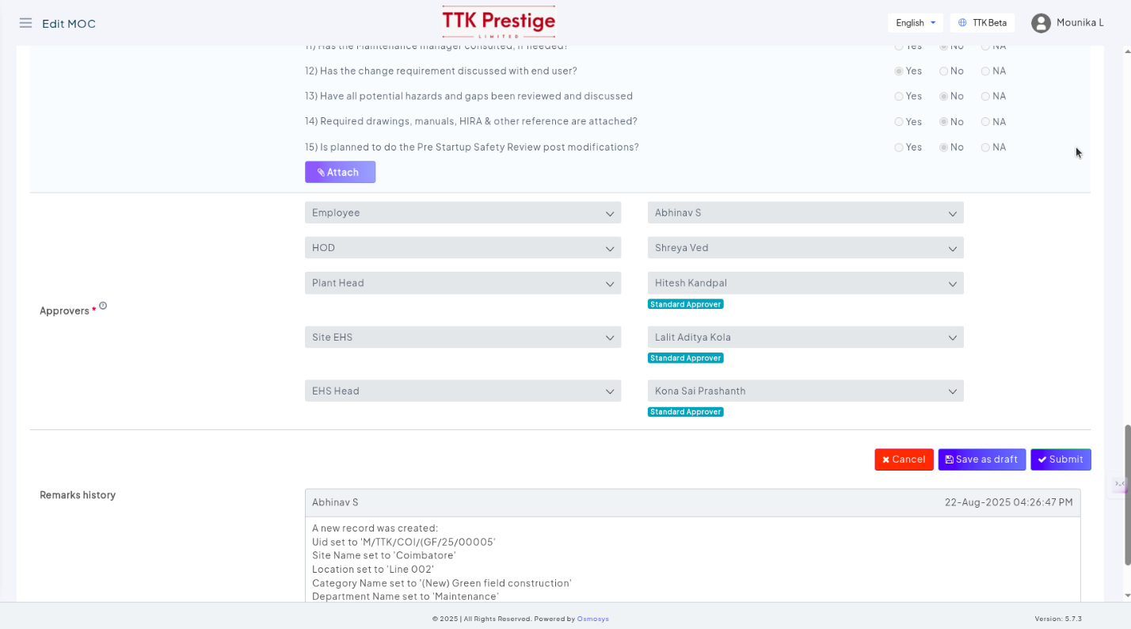
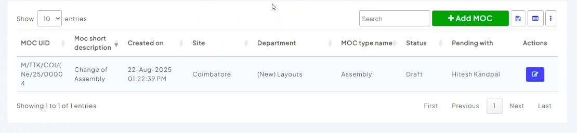
2. The email should be updated (more details like description and all are needed).
The link in the email is not clickable. Not hyperlinked. [Dhruv]
When we copy and opening the link given in the email, it is redirecting to 404 page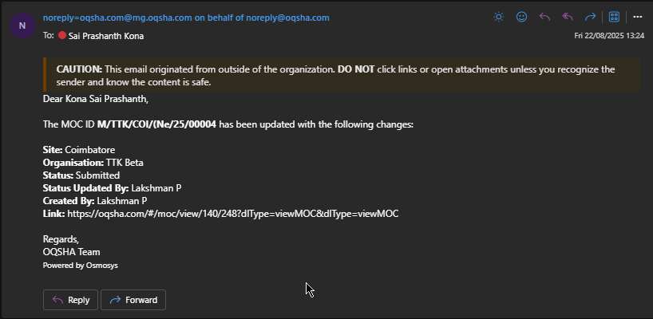
3. When we add the approvers details by clicking on + while creating or updating the MOC. The details are not stored in track history. [API]
5. All the emails should go only to the initiator. But here all approvers are getting the emails for every update(adding the clarify questions) other approvers are doing. [API]
If the initiator replies to a question that approver asks then that particular approver needs to get the email. [API]
6. The status should be clarification instead of clarified – not a priority [Dhruv+API change]
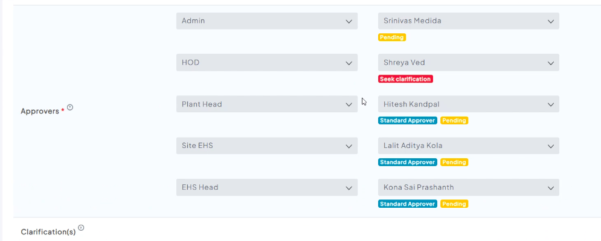
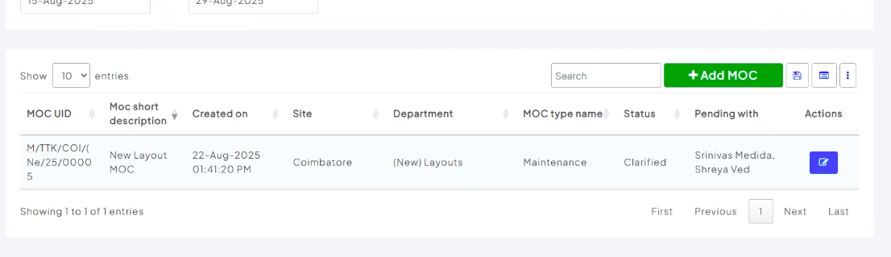
7 .The status under the approver names are getting updated incorrectly. When all the approvers are adding the clarify questions, for all we need to get seek clarification status. But here when person 1 is adding the question – for that name can see the seek clarification status.
Now after that person 2 is adding the question – the person 1 is in pending status even though that question is not clarified yet and person 2 status is in seek clarification status. {API]
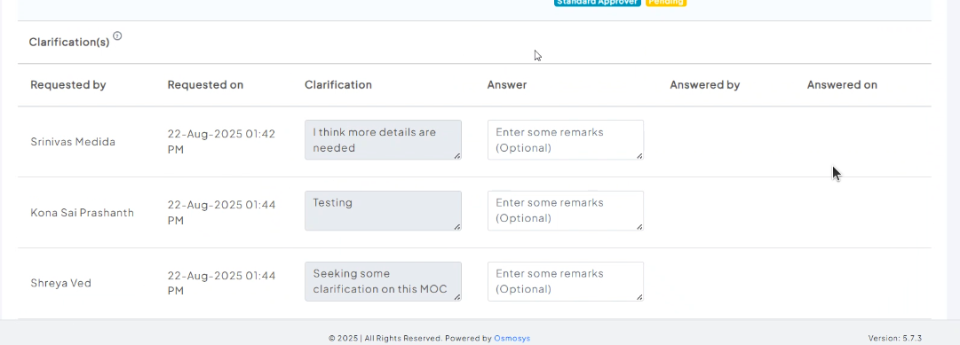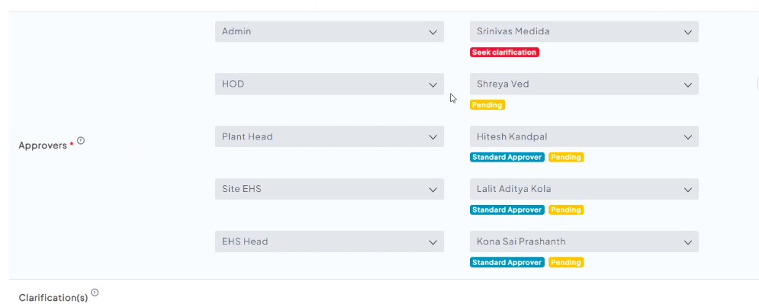
8. The below is for Department (New) Layouts - @Lalit Aditya Kola please have a look into this department.
Approve button is working for the plant Head. Assuming, the Approve button is not working when we are adding clarifications and replying to them.
Case 1: Even though able to see the approve button and clicking on that.
Able to see the MOC updated successfully but the update is not happening.
Also the update button is disabled even though I have added data in remarks field.
Case 2: When we write any remark and click on the approve, the remark is getting added but approve is not happening. (Double check with Mounika)
9. When the user have access to only one site like Coimbatore, then by default his site should be Coimbatore, instead of selecting from the dropdown. (Preselect first option [Aditya])
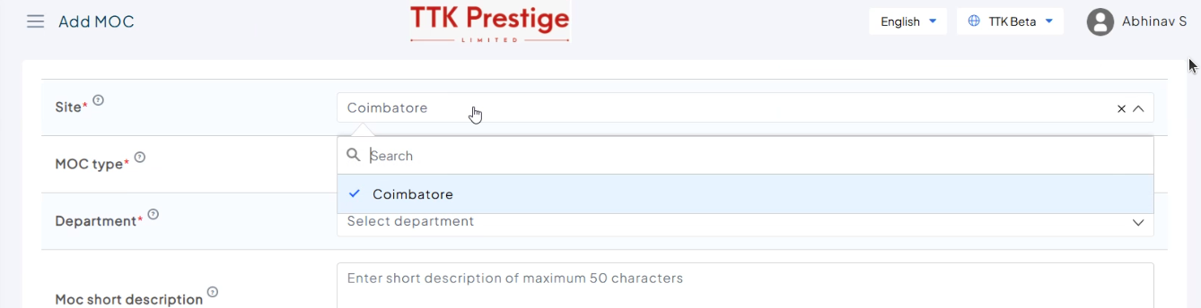

10. Moc short description – MOC should be in capital. [Dhruv]
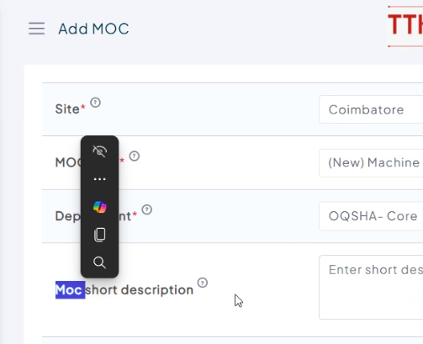
11. All the approvers order should be same. Shouldn’t be based on the MOC types. - @Lalit Aditya Kola (Clarify with Mounika – it is configured from setup page)
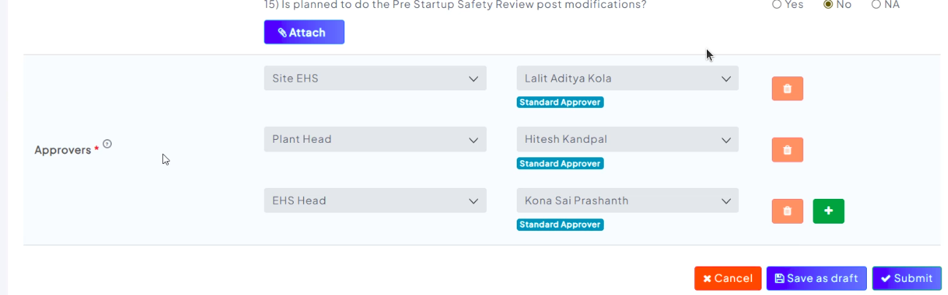
12. From the MOC Create PSSR button should be enabled only for the initiator. Currently all the people can create PSSR from the MOC. [Dhruv]
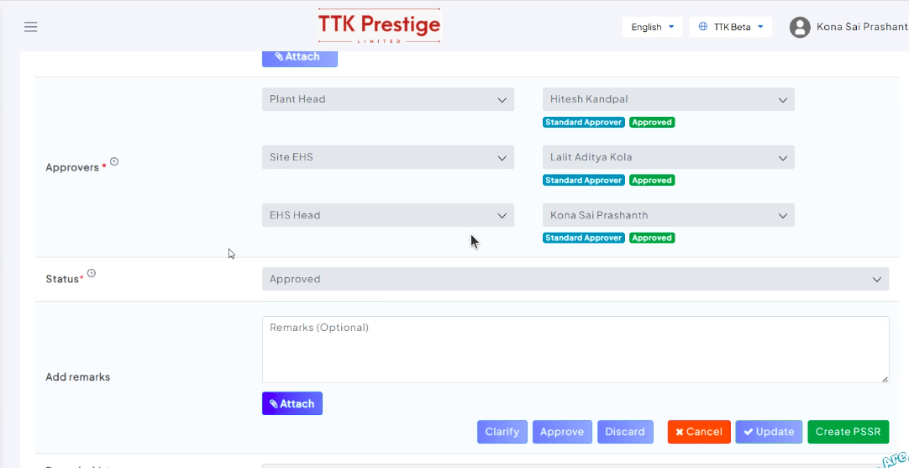
13. The first and last approvers comments are only being tracked, the middle approvers approvals are not being tracked.
The middle approvers approval is only being tracked when the middle approvers are asking for clarifications. When they are not asking for any clarifications then we are not getting any approval data in the track history. [API]
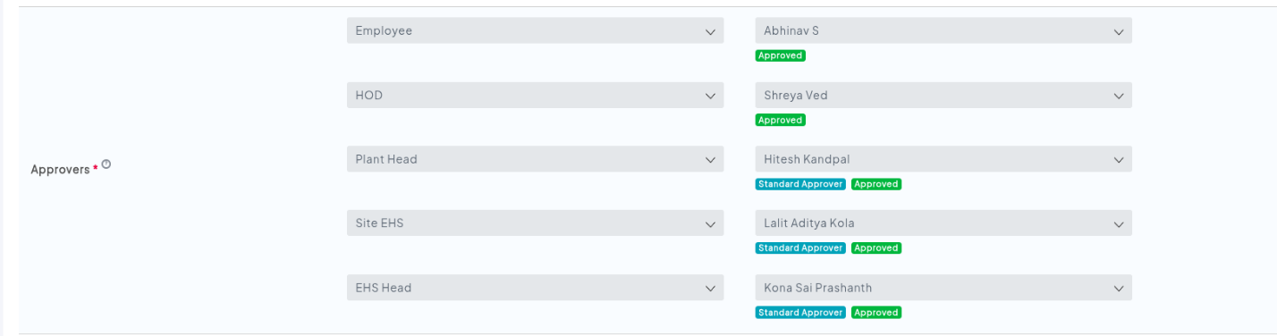
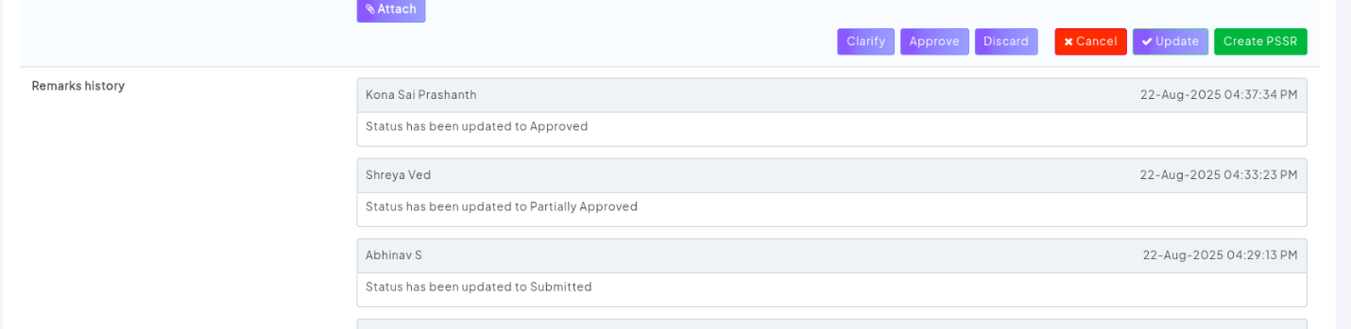
14. While creating PSSR, need to see the save as draft button. -- new requirement. [Dhruv]
15. Preview of the image is not there in all the modules. [Aditya]
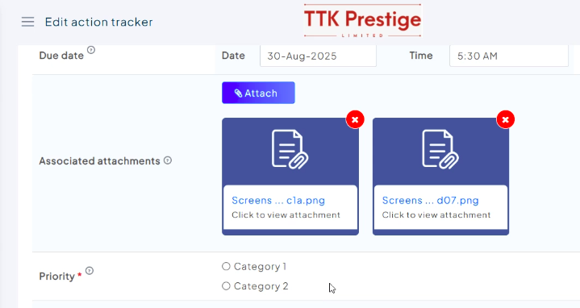
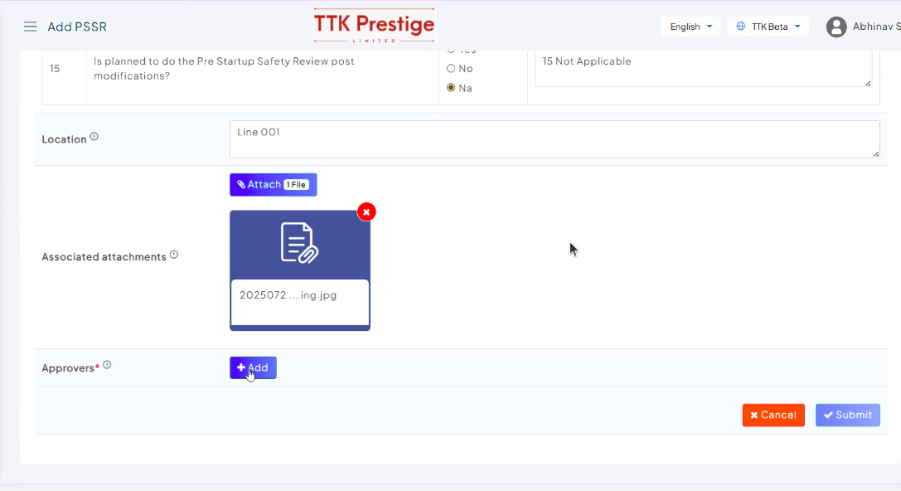
16. Instead of Approvers, rename as PSSR team in PSSR. [Aditya]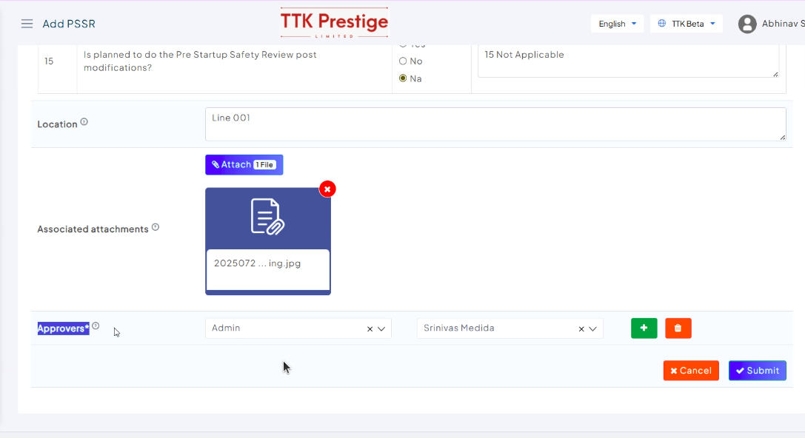
17. Able to see the user who are not there in the org(neither active or inactive) [API + Dhruv]
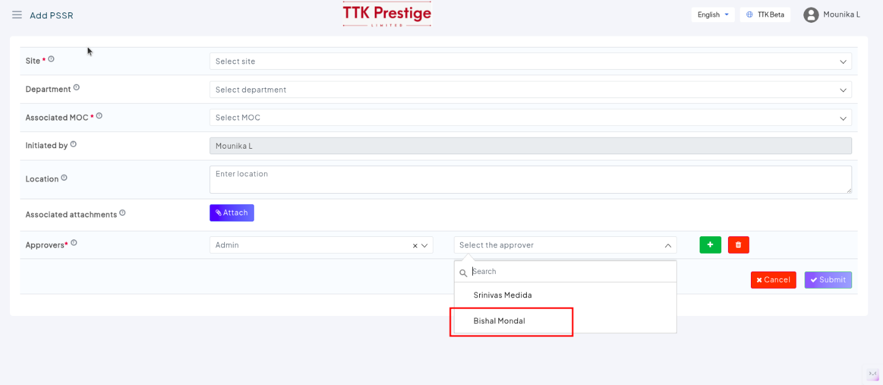
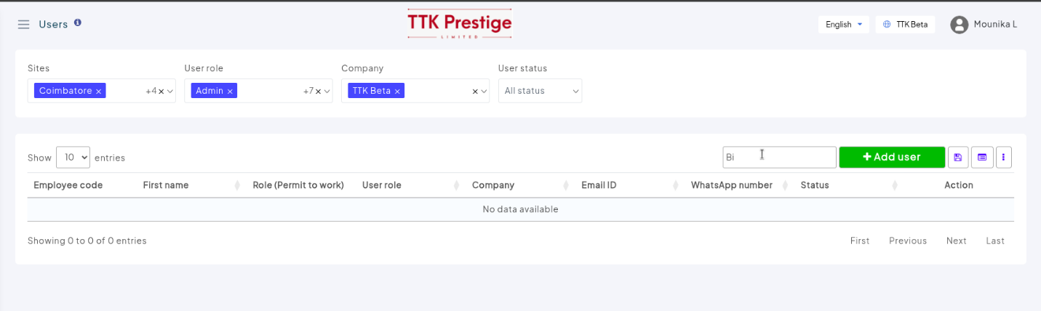
18. Even though I’m a part of the approvers, I’m able to edit all the details.
We shouldn’t be able to edit all the details like the Checklist and Details also.
We only need the action tacker details to be enabled. [Get it clarified from MS + Aditya]
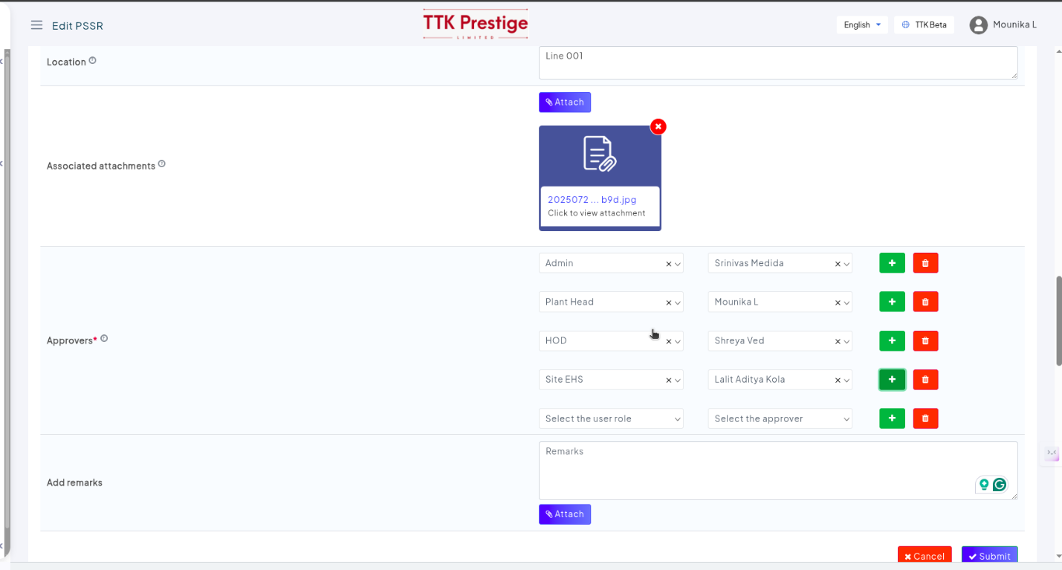
19. When we create a PSSR (action tracker) from the MOC, the default assigned to should be initiator. Currently it is just a dropdown, and we need to select. [Dhruv]
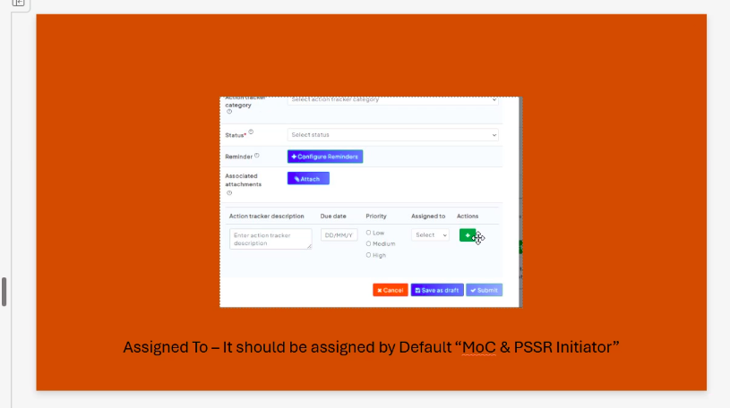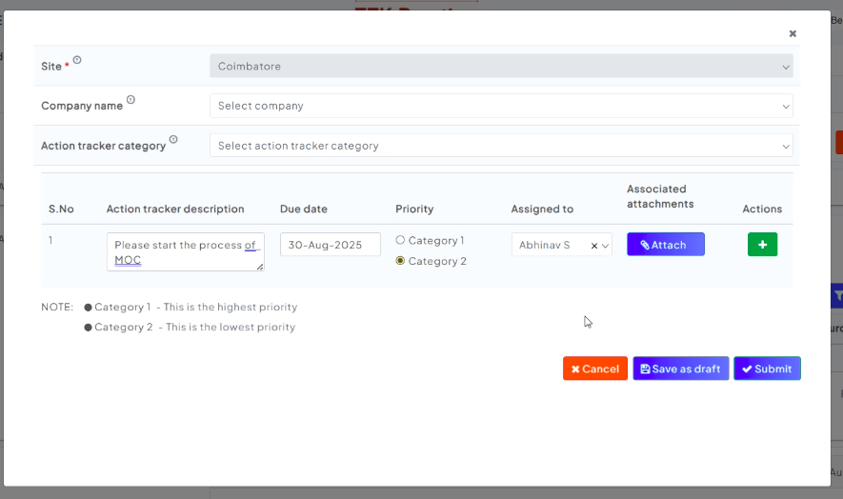
20. When we create a single action tracker, we don’t need the below pop-up message [Dhruv]
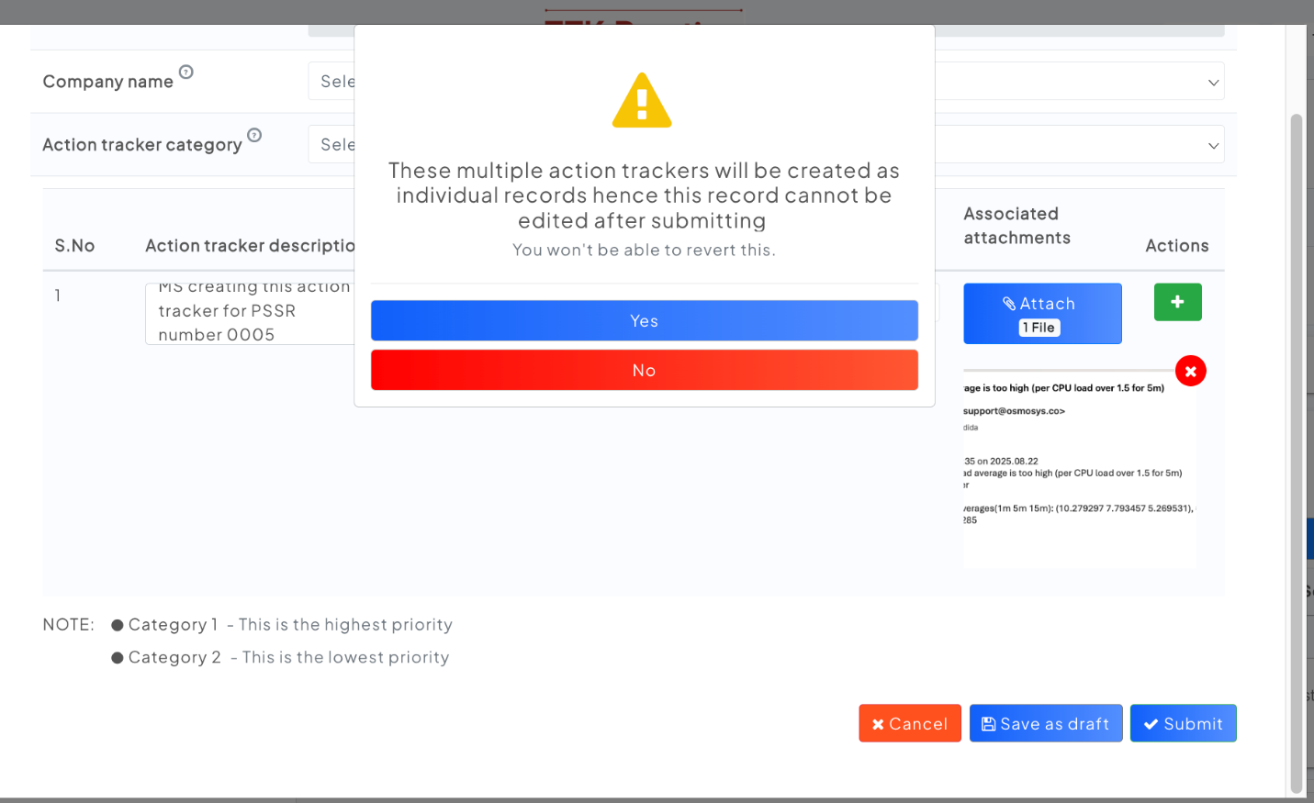

21. Action tracker list page - Sorting is happening based on Task description, It should be based on Created On [Aditya]
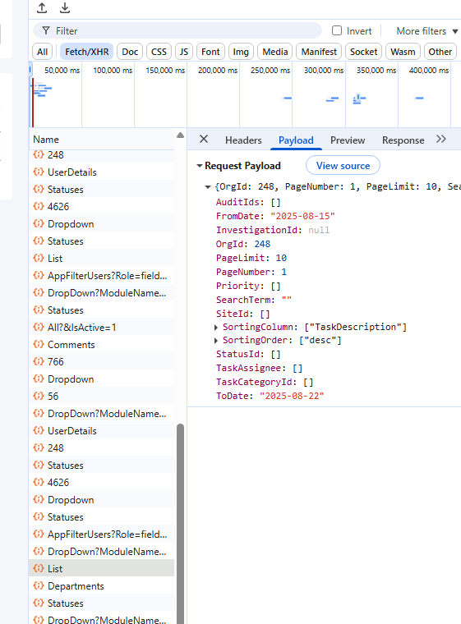
22. Export PSSR needed for PSSR list page for exporting into excel same and uniform as all modules [API]
23. Action tracker needs a closure button. [Rupam has a task for it]
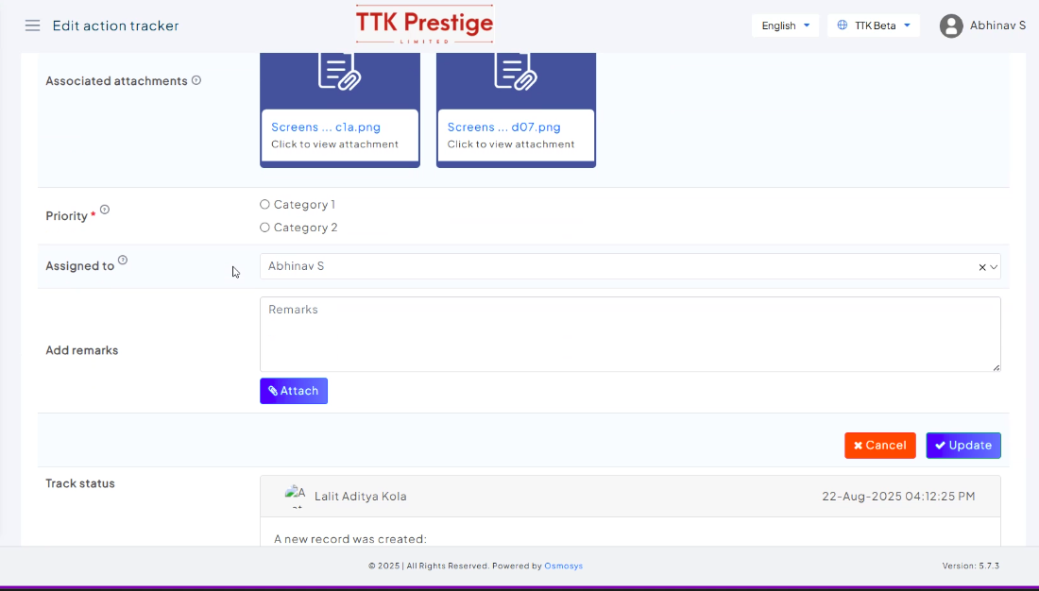
24. When an MOC is deleted - associated PSSR also should be deleted [API+Aditya(update modal message)]
25. It should be Department is required instead of MOC department is required. [Dhruv]
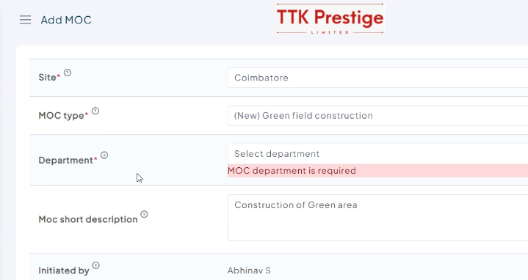
26. In MOC - Submit or save a draft button should not be visible for any others expect for the initiator. [Dhruv]
27. Powered by Osmosys is missing from the MOC waiting for approval email. Like when we compare to the rest of the mails like update MOC, can see that line. [API]
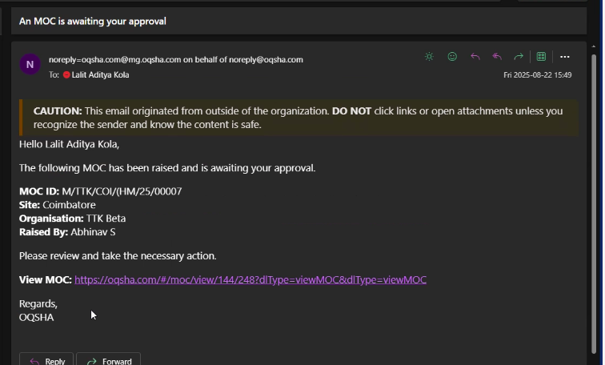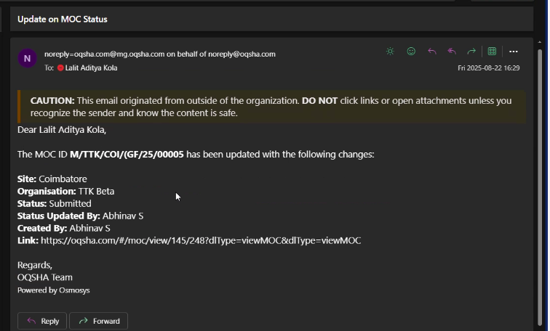
28. The disable and enable buttons colors can be improved. The disabled color should be duller. (on hold)
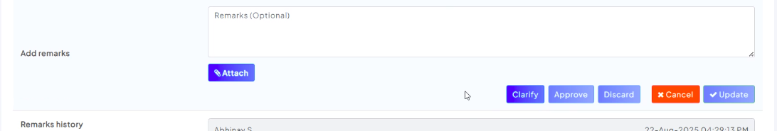
29. The emails are not received for approvers or the initiator.
This is happening when we directly submit the MOC but we are to receive when we are save a draft and submit. [API]
30. If a approver approves the MOC, he don’t need to stay in the edit page, he should be redirected to the grid page. (Covered in first point, Aditya)
31. Email subject can be improved. Like currently it is showing as An approver has updated instead of the approver name. [API]
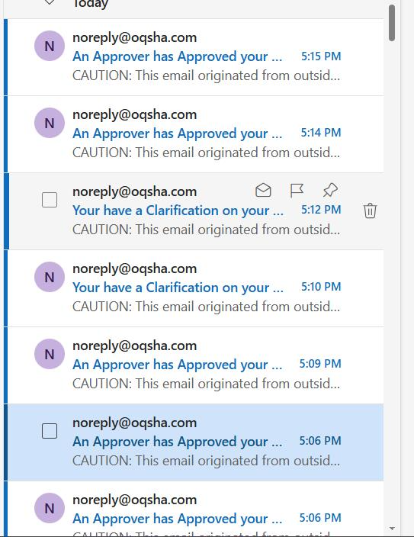
32. All the modules, the sort should be appropriate. Discuss and set it. (Sorting should be on created on for all pages, latest record should be on top)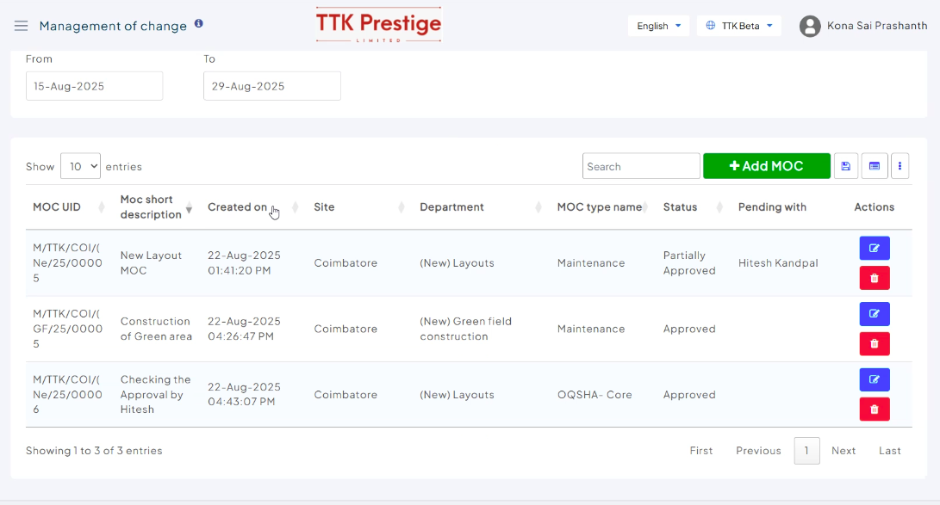
33. When we go to the action tracker from the PSSR – the field Associated action trackers, and updating the action tracker then we need to go the PSSR grid instead of the action tracker grid. [Aditya – do for all associated tasks modules]
34. In all the modules - No alternate text or image should be there when there is no profile image. [Aditya]
35. Update value sent in payload for Category ½ priority options in action tracker page [API]
