

Term work
on
Design & Analysis of Algorithms
LAB
( PCS 409)
2021-22

Submitted to: Submitted by:

Dilip Kumar Gangwar Garvit Grover
Asst. Professor University Roll No.:2018338

GEHU, D.Dun Class Roll no./Section:20/A

DEPARTMENT OF COMPUTER SCIENCE AND ENGINEERING

GRAPHIC ERA HILL UNIVERSITY, DEHRADUN

ACKNOWLEDGMENT

I would like to particularly thank my DAA Lab Faculty Mr. Dilip Kumar Gangwar for his patience, support and encouragement throughout the completion of this Term work.
At last, but not the least I greatly indebted to all other persons who directly or indirectly helped me during this course.
Garvit Grover
Univ. Roll No.:2018338
B.Tech CSE-A-IV Sem
Session: 2021-2022 GEHU, Dehradun

Table of Contents

Program No. | Program Name | Page No
1 | Program to Implement Linear Search Method and also find TotalNo of Comparisons.
2 | Program to find whether given key element is present in thearray or not and also total number of comparisons.
3 | Program to find whether a given key element is present in the sorted array or not. For an array arr[n], search at the indexes arr[0], arr[2], arr[4],. ,arr[2^{k}] and so on. Once the interval (arr[2^{k}]  < key < arr[ 2^{k+1}] ) is found, perform a linear search operationfrom the index 2^{k} to find the element key.
4 | Program to find whether the given key element is present in thearray or not. If present, then also find the number of copies of given key.
5 | Program to find three indices i, j, k such that arr[i] + arr[j] =arr[k].
6 | Program to count the number of pairs of integers such that their difference is equal to a given key, K.
7 | Program to sort the array using insertion sort. Find number of comparisons and shifts required for sorting the array.
8 | Program to sort this array using selection sort. Also find numberof comparisons and number of swaps required.
9 | Program to find whether there are any duplicate elements in thearray or not.
10 | Program to sort an array of elements by dividing the array into two subarrays and combining these subarrays after sorting eachone of them. Also find number of comparisons and inversions during sorting the array.
11 | Program to sort an array of elements by partitioning the array into two subarrays based on a pivot element such that one of the sub array holds values smaller than the pivot element whileanother sub array holds values greater than the pivot element. Pivot element should be selected randomly from the array. Also

 | find number of comparisons and swaps required for sorting thearray.
12 | Program to find Kth smallest or largest element in the array.
13 | Program to find which alphabet has maximum number of occurrences and print it.
14 | Program to find whether two elements exist such that their sumis equal to the given key element.
15 | Program to find list of elements which are common to both thegiven sorted arrays.



DEPARTMENT OF CSE STUDENT LAB REPORT SHEET

Photograph Passport Size
Name of Student .................................................... Mob. No ......................................
Address Permanent .....................................................................................................
Father’s Name ........................... Occupation ...................... Mob. No .......................
Mother’s Name ........................... Occupation ...................... Mob. No .......................
Section ............ Branch ............ Semester ........... Class Roll No Grade A B C
Local Address ................................... Email ............................................ Marks 5 3 1

S.N  o. | Practical | D.O.P. | Date of Submiss ion | Grade (Viva) | Grade (Report File) | Total Marks (out of 10) | Student’s Signature | Teacher’s Signature
1 | Program-01
2 | Program-02
3 | Program-03
4 | Program-04
5 | Program-05
6 | Program-06
7 | Program-07
8 | Program-08
9 | Program-09
10 | Program-10

11 | Program-11
12 | Program-12
13 | Program-13
14 | Program-14
15 | Program-15

Program 1
1.Given an array of nonnegative integers, design a linear algorithm and implement it using aprogram to find whether given key element is present in the array or not. Also, find total number of comparisons for each input case. (Time Complexity = O(n), where n is the size of input)

Algorithm:
Algorithm linearSearch(a[0…n-1],n,key)
{
no_of_comparisons = 0 for i=0 to n
{
no_of_comparisons++ if(a[i] == key)
Print “ key is found”
return no_of_comparisons
}
if(i==n)
Print “ key is NOT found” return no_of_comparisons
}

Complexity Analysis:
Time Complexity:
Worst Case: T(n) = θ(𝑛) Best Case: T(n)= Ω(1) Average Case:T(n) = θ(𝑛) Space Complexity:
Worst Case=Best Case = Average case = θ(1)

Source code:
/*
Name: Garvit Grover
Univ. Roll No: 2018338
Section : A
*/

#include <iostream> using namespace std; int main()
{
int t;
cout<<"enter no. of test:";

cin>>t; while(t!=0)
{
int n;
cout<<"\nenter the size of array"<<endl; cin>>n;
cout<<"enter the element of array"<<endl; int arr[n];
for(int i=0;i<n;i++) cin>>arr[i];
int key;
cout<<"enter the key: "; cin>>key;
int c=0,f=0;
for(int i=0;i<n;i++)
{
c++;
if(arr[i]==key)
{
cout<<endl<<key<<" found"<<endl; cout<<"Number of comparision :"; cout<<c<<endl;
f=1;
break;
}
}
if(f==0)
cout<<key<<" not found"<<endl; t--;
}
return 0;}

Output
/*
Name: Garvit Grover
Univ. Roll No: 2018338
Section : A
*/
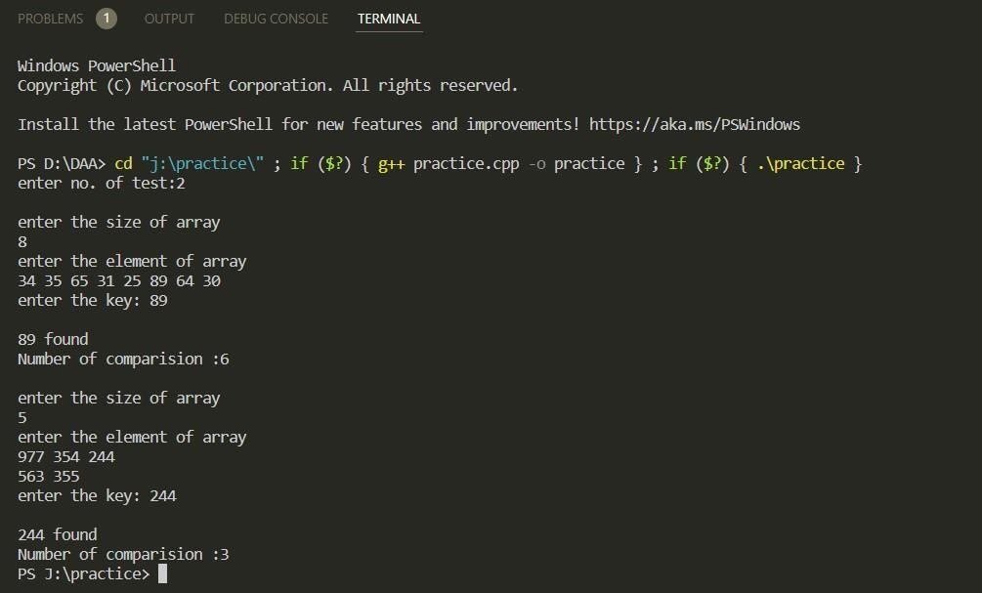

Program 2
2.Given an already sorted array of positive integers, design an algorithm and implement it using a program to find whether given key element is present in the array or not. Also, find total number of comparisons for each input case. (Time Complexity = O(logn), where n is the size of input).

Algorithm:
Binary_Search(a, lower_bound, upper_bound, val)
Step 1: set beg = lower_bound, end = upper_bound, pos = - 1 Step 2: repeat steps 3 and 4 while beg <=end
Step 3: set mid = (beg + end)/2 Step 4: if a[mid] = val
set pos = mid print pos
go to step 6
else if a[mid] > val set end = mid - 1 else
set beg = mid + 1 [end of if]
[end of loop]
Step 5: if pos = -1
print "value is not present in the array" [end of if]
Step 6: exit

Complexity Analysis:
Time Complexity:
Worst Case: T(n) = θlog(𝑛) Best Case: T(n)= Ω(1) Average Case:T(n) = θlog(𝑛) Space Complexity:
Worst Case=Best Case = Average case = θ(1) [ Constant ]

Source code :
/*
Name: Garvit Grover
Univ. Roll No: 2018338
Section : A
*/

#include <iostream> using namespace std;
void binary(int *arr,int n,int key)
{
int l=0,r=n-1; int c=0; while(l<r)
{
int mid=(l+r)/2; c++;
if(arr[mid]==key)
{
cout<<key<<" found"<<endl; cout<<"number of comparision"<<endl; cout<<c;
return ;
}
if(arr[mid]>key) r=mid-1;
else l=mid+1;
}
cout<<key<<" not found"<<endl; cout<<"number of comparision:"; cout<<c<<endl;
return ;
}
int main()
{
int t;
cout<<"enter no. of test"<<endl;

cin>>t; while(t!=0)
{
int n;
cout<<"\nEnter the size of array"<<endl; cin>>n;
cout<<"enter the element of array"<<endl; int arr[n];
for(int i=0;i<n;i++) cin>>arr[i];
int key;
cout<<"enter the key"<<endl; cin>>key;
int c=0; binary(arr,n,key); t--;
}
return 0;
}

Output :
/*
Name: Garvit Grover
Univ. Roll No: 2018338
Section : A
*/

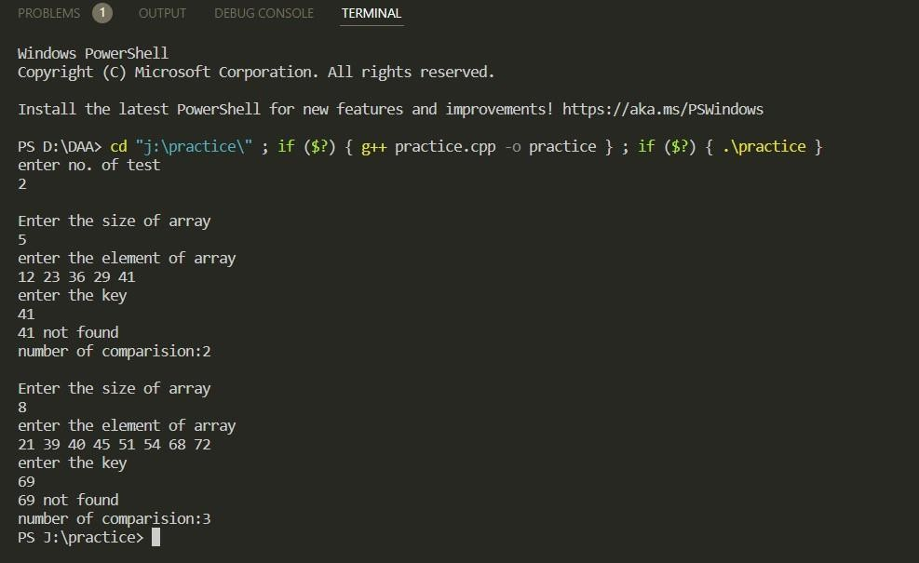

Program 3
3.Given an already sorted array of positive integers, design an algorithm and implement it using a program to find whether a given key element is present in the sorted array or not. For an array arr[n], search at the indexes arr[0], arr[2], arr[4],. ,arr[2 k ] and so on. Once the interval (arr[2 k ] < key < arr[ 2 k+1 ] ) is found, perform a linear search operation from the index 2 k to find the element key. (Complexity < O(n), where n is the number of elements need to be scanned for searching): (Jump Search)

Algorithm:
Algorithm JumpSearch(a[0…n-1],n,key) Step 1: set r=2^1,i=1
Step 2: repeat steps 3 and 4 while r <=n Step 3: if a[r]<key
for j=i-1 to r
if a[j]== key print found
exit

Step 4:i=r, r=2^i Step 5:if r>n then
for j=i-1 to n if a[j]== key
print found exit
Step 6:print not found Step 7:exit Complexity Analysis:

Time Complexity:
Worst Case: T(n) = θ(sqrt 𝑛) Best Case: T(n)= Ω(sqrt n) Average Case:T(n) = θ(sqrt 𝑛) Space Complexity:
Worst Case=Best Case = Average case = θ(1)

Source code :
/*
Name: Garvit Grover
Univ. Roll No: 2018338
Section : A
*/

#include <iostream> #include <math.h> using namespace std;
void jumpsearch(int *arr,int n,int key)
{int r=pow(2,1); int l=0;
int i=1; int c=0;
while(r<=n)
{
c++;
if(arr[r]<arr[i])
{
for(int j=l;j<=r;j++)
{ c++;
if(arr[j]==key)
{
cout<<key<<" found"<<endl; cout<<"number of comparision"<<endl; cout<<c;
return ;
}
}
}
i++;
l=r; r=pow(2,i);
}
if(r>n)
{

for(int j=l;j<n;j++)
{ c++;
if(arr[j]==key)
{
cout<<key<<" found"<<endl; cout<<"number of comparision"<<endl; cout<<c;
return ;
}
}
}
cout<<key<<" not found"<<endl; cout<<"number of comparision"<<endl; cout<<c;
return ;
}
int main()
{
int t;
cout<<"enter no. of test"<<endl; cin>>t;
while(t!=0)
{
int n;
cout<<"enter the size of array"<<endl; cin>>n;
cout<<"enter the element of array"<<endl; int arr[n];
for(int i=0;i<n;i++) cin>>arr[i];
int key;

cout<<"enter the key"<<endl; cin>>key; jumpsearch(arr,n,key);
t--;
} return 0;}

Output:
/*
Name: Garvit Grover
Univ. Roll No: 2018338
Section : A
*/
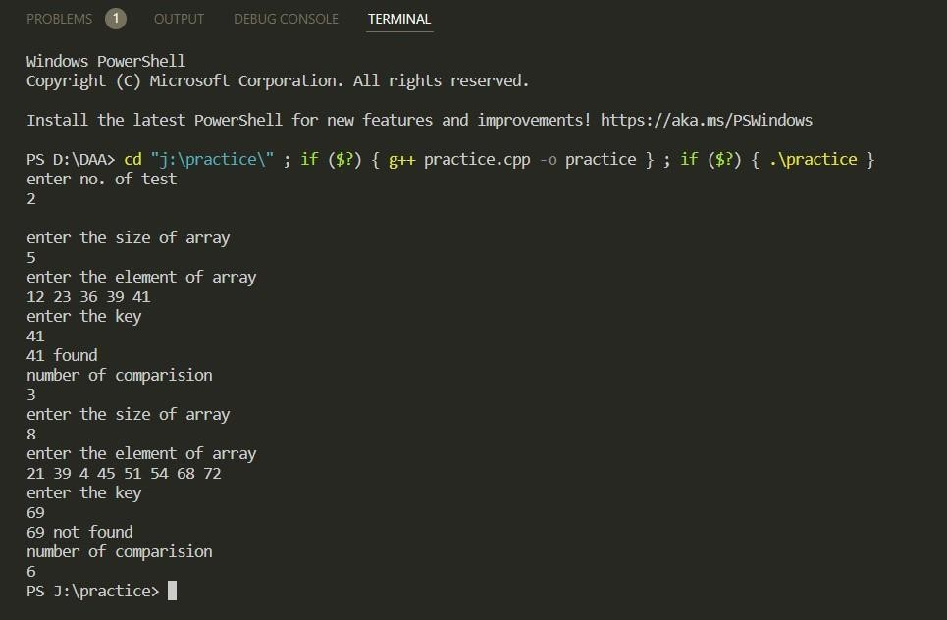

Program 4
4.Given a sorted array of positive integers containing few duplicate elements, design an algorithm and implement it using a program to find whether the given key element is present in the array or not. If present, then also find the number of copies of given key. (Time Complexity = O(log n))

Algorithm:
Step 1: find fist occurance of key using binary search Step 2:find last occurance of key using binary search Step 3: set freq=last occurance – first occurance +1 Step 4: if freq >1
Print freq Else
Print no duplicate Step 5 exit

Complexity Analysis:
Time Complexity:
Worst Case: T(n) = θlog(𝑛) Best Case: T(n)= Ω(1) Average Case:T(n) = θlog(𝑛) Space Complexity:
Worst Case=Best Case = Average case = θ(1) [ Constant ]

Source code :
/*
Name: Garvit Grover
Univ. Roll No: 2018338
Section : A
*/

#include <iostream> using namespace std;
int first(int *arr,int l,int r,int key,int n)
{
if(l<=r)
{
int mid1=l+(r-l)/2;
if((mid1==0||arr[mid1-1]<key)&&arr[mid1]==key) return mid1;
else if(arr[mid1]<key)

return first(arr,mid1+1,r,key,n); else
return first(arr,l,mid1-1,key,n);
}
return -1;
}
int last(int *arr,int l,int r,int key,int n)
{
if(l<=r)
{
int mid2=l+(r-l)/2;
if((mid2==n-1||arr[mid2+1]>key)&&arr[mid2]==key) return mid2;
else if(arr[mid2]>key)
return last(arr,l,mid2-1,key,n); else
return last(arr,mid2+1,r,key,n);
}
return -1;
}
int main()
{
int T,n,key;
cout<<"Enter no. of test cases: "; cin>>T;
while(T)
{
cout<<"\n\nEnter the size of array: "; cin>>n;
cout<<"Enter the elements of array: "; int arr[n];
for(int i=0;i<n;i++) cin>>arr[i];

cout<<"Enter the key to be searched: "; cin>>key;
int diff=last(arr,0,n-1,key,n)-first(arr,0,n-1,key,n)+1; if(diff>0)
{
cout<<key<<"-"<<diff<<endl;
}
else
cout<<"Key not present"<<endl; T--;
}
}

Output:
/*
Name: Garvit Grover
Univ. Roll No: 2018338
Section : A
*/
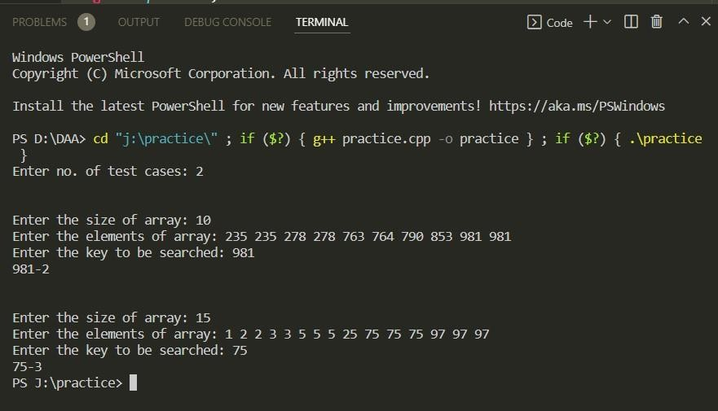

Program 5
5.Given a sorted array of positive integers, design an algorithm and implement it using a program to find three indices i, j, k such that arr[i] + arr[j] = arr[k].

Algorithm:
Step 1: for i=0 to n-2
for j=i+1 to n-1 for k=j+1 to n
if arr[i]+arr[j]==arr[k] print i j k
exit
Step 2: print not found Step 3: exit Complexity Analysis:

Time Complexity:
Worst Case: T(n) = θ(𝑛^3) Best Case: T(n)= Ω(n^3) Average Case:T(n) = θ(𝑛^3) Space Complexity:
Worst Case=Best Case = Average case = θ(1) [ Constant ]

Source code:
/*
Name: Garvit Grover
Univ. Roll No: 2018338
Section : A
*/

#include <iostream> using namespace std; int main()
{
int T,n;
cout<<"Enter no. of test cases: "; cin>>T;
while(T){

cout<<"\n\nEnter the size of array: "; cin>>n;
cout<<"Enter the elements of array: "; int arr[n];
for(int i=0;i<n;i++) cin>>arr[i];
int f=0;
for(int i=0;i<n-2;i++){ for(int j=i+1;j<n-1;j++){
for(int k=j+1;k<n;k++)
{
if(arr[i]+arr[j]==arr[k])
{
cout<<i<<" "<<j<<" "<<k; f=1;
break;
}
}
if(f==1) break;
}
if(f==1) break;
}
if(f==0)
cout<<"not found"; T--;
} }

Output
/*
Name: Garvit Grover
Univ. Roll No: 2018338
Section : A
*/

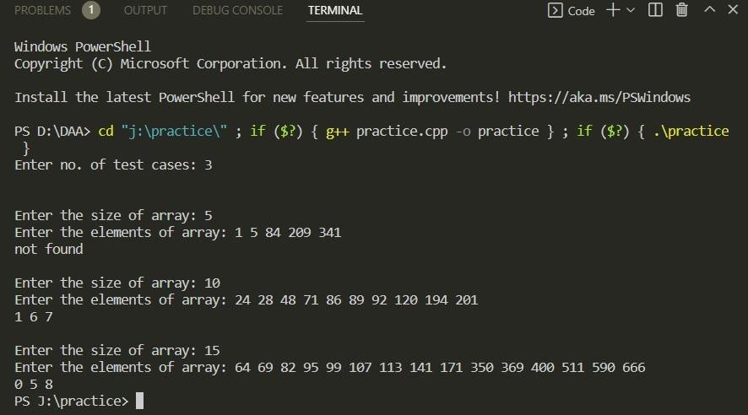

Program 6
6.Given an array of nonnegative integers, design an algorithm and a program to count the number of pairs of integers such that their difference is equal to a given key, K.

Algorithm:
Step 1: for i=0 to n-1
for j=i+1 to n
if arr[i]-arr[j]==key print arr[i] arr[j]
Step 2: print not such pair Step 3 : exit

Complexity Analysis:
Time Complexity:
Worst Case: T(n) = θ(𝑛^2) Best Case: T(n)= Ω(n^2) Average Case:T(n) = θ(𝑛^2) Space Complexity:
Worst Case=Best Case = Average case = θ(1) [ Constant ]

Source code :
/*
Name: Garvit Grover
Univ. Roll No: 2018338
Section : A
*/

#include <iostream> using namespace std; int main()
{
int T,n,k;
cout<<"Enter no. of test cases: "; cin>>T;
while(T)
{
cout<<"\n\nEnter the size of array: "; cin>>n;
cout<<"Enter the elements of array: "; int arr[n];
for(int i=0;i<n;i++)
{
cin>>arr[i];
}
int f=0; int k;
cout<<"enter key"<<endl; cin>>k;
for(int i=0;i<n-1;i++)
{
for(int j=i+1;j<n;j++)
{
if(arr[i]-arr[j]==k||arr[j]-arr[i]==k) f++;
}
}
cout<<f; T--;
}
}

Output
/*
Name: Garvit Grover
Univ. Roll No: 2018338
Section : A
*/
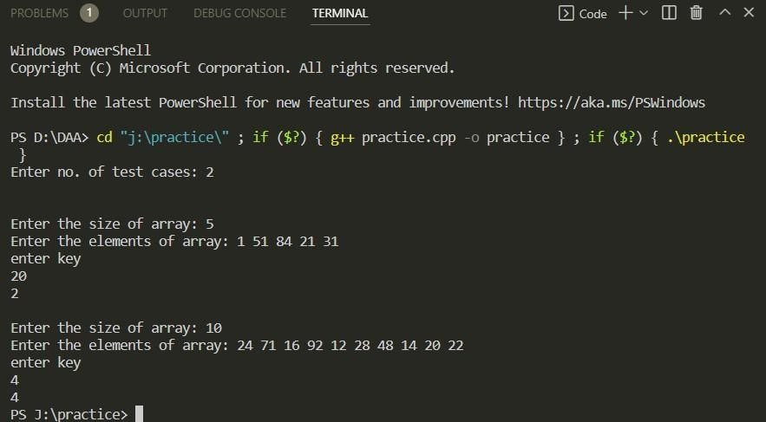

Program 7
7.Given an unsorted array of integers, design an algorithm and a program to sort the array using insertion sort. Your program should be able to find number of comparisons and shifts ( shifts - total number of times the array elements are shifted from their place) required for sorting the array.

Algorithm:
Step 1 - If the element is the first element, assume that it is already sorted. Return 1. Step2 - Pick the next element, and store it separately in a key.
Step3 - Now, compare the key with all elements in the sorted array.
Step 4 - If the element in the sorted array is smaller than the current element, then move to the next element. Else, shift greater elements in the array towards the right.
Step 5 - Insert the value.
Step 6 - Repeat until the array is sorted.

Complexity Analysis:
Time Complexity:
Worst Case: T(n) = θ(𝑛^2) Best Case: T(n)= Ω(n) Average Case:T(n) = θ(𝑛^2) Space Complexity:
Worst Case=Best Case = Average case = θ(1) [ Constant ]
Source code :
/*
Name: Garvit Grover
Univ. Roll No: 2018338
Section : A
*/

#include <iostream> #include <algorithm> using namespace std; int main()
{
int t;
cout<<"enter no. of test"<<endl; cin>>t;
while(t!=0)
{
int n;
cout<<"\n\nenter the size of array"<<endl;

cin>>n; int arr[n]; int j;
int c=0,s=0;
cout<<"enter the element of array"<<endl; for(int i=0;i<n;i++)
{
cin>>arr[i];
int temp=arr[i]; j=i-1;
while(j>=0&&temp<arr[j])
{
arr[j+1]=arr[j]; c++;
s++; j--;
}
arr[j+1]=temp; s++;
}
for(int i=0;i<n;i++)
{
cout<<arr[i]<<" ";
}
cout<<"\ncomparision "<<c<<endl; cout<<"shifts "<<s-1<<endl;
t--;}}

Output
/*
Name: Garvit Grover
Univ. Roll No: 2018338
Section : A
*/

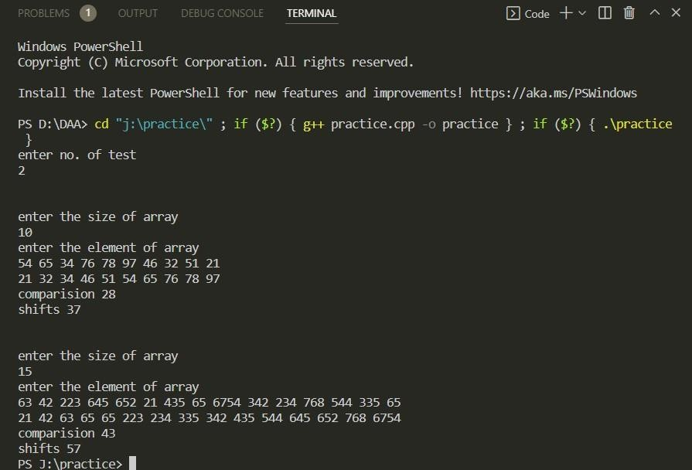

Program 8
8.Given an unsorted array of integers, design an algorithm and implement a program to sort this array using selection sort. Your program should also find number of comparisons and number of swaps required.

Algorithm:
Step 1 − Set MIN to location 0
Step 2 − Search the minimum element in the list Step 3 − Swap with value at location MIN
Step 4 − Increment MIN to point to next element Step 5 − Repeat until list is sorted

Complexity Analysis:
Time Complexity:
Worst Case: T(n) = θ(𝑛^2) Best Case: T(n)= Ω(n^2) Average Case:T(n) = θ(𝑛^2) Space Complexity:
Worst Case=Best Case = Average case = θ(1) [ Constant ]
Source code :
/*
Name: Garvit Grover
Univ. Roll No: 2018338
Section : A
*/
#include <iostream>
include <algorithm> using namespace std;
Int main()
{
int t;
cout<<"enter no. of test"<<endl; cin>>t;
while(t!=0)
{
int n;
cout<<"enter the size of array"<<endl; cin>>n;
int arr[n]; int j;
int c=0,s=0;
cout<<"enter the element of array"<<endl; for(int i=0;i<n;i++)
{
cin>>arr[i];
}
for(int i=0;i<n;i++)
{
int k=i;
for(int j=i+1;j<n;j++)
{
c++;
if(arr[k]>arr[j]) k=j;
}
s++;
swap(arr[i],arr[k]);
}
for(int i=0;i<n;i++)
{
cout<<arr[i]<<" ";
}
cout<<"comparision "<<c<<endl; cout<<"swaps "<<s-1<<endl;
t--;
} }

Output
/*
Name: Garvit Grover
Univ. Roll No: 2018338
Section : A
*/

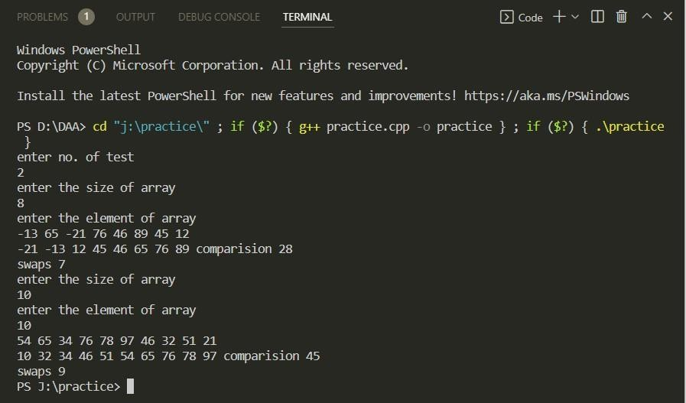

Program 9
9.Given an unsorted array of positive integers, design an algorithm and implement it using a program to find whether there are any duplicate elements in the array or not. (use sorting) (Time Complexity = O(n log n))

Algorithm:
Step1: sort the array using merge sort Step2:repeat for i=0 to n
If array[i]==array[i+1] then Print duplicate found Jump to step 4
Step3: print no duplicate found Step4:exit

Complexity Analysis:
Time Complexity:
Worst Case: T(n) = θ(𝑛logn) Best Case: T(n)= Ω(nlogn) Average Case:T(n) = θ(nlogn) Space Complexity:
Worst Case=Best Case = Average case = θ(n) [ Constant ]

Source code :
/*
Name: Garvit Grover
Univ. Roll No: 2018338
Section : A
*/
#include <iostream> #include <algorithm> using namespace std;
void merge(int *arr,int l,int e,int mid)
{
int i=0,j=0,k=l; int n1=mid-l+1; int n2=e-mid; int L[n1];
int R[n2];
for(int i=0;i<n1;i++)
{

L[i]=arr[l+i];
}
for(int i=0;i<n2;i++)
{
R[i]=arr[mid+1+i];
}
while(i<n1&&j<n2)
{
if(L[i]<=R[j])
{
arr[k]=L[i]; i++;
}
else
{
arr[k]=R[j]; j++;
}
k++;
}
while(i<n1)
{
arr[k]=L[i]; i++;
k++;
}
while(j<n2)
{
arr[k]=R[j]; j++;
k++;
}
void mergesort(int *arr,int l,int e)
{
if(l<e)
{
int mid=l+(e-l)/2; mergesort(arr,l,mid); mergesort(arr,mid+1,e); merge(arr,l,e,mid);
}
}
int main()
{
int t;
cout<<"enter no. of test"<<endl; cin>>t;
while(t!=0)
{
int n;
cout<<"\nEnter the size: "; cin>>n;
int arr[n]; int j;
cout<<"enter the element of array"<<endl; for(int i=0;i<n;i++)
{
cin>>arr[i];
}
mergesort(arr,0,n-1); int f=1;
for(int i=0;i<n;i++)

{
if(arr[i]==arr[i+1])
{
cout<<"\nyes"<<endl; f=0;
break;
}
}
if(f==1)
{
cout<<"\nno"<<endl;
}
t--;
}
}

Output
/*
Name: Garvit Grover
Univ. Roll No: 2018338
Section : A
*/
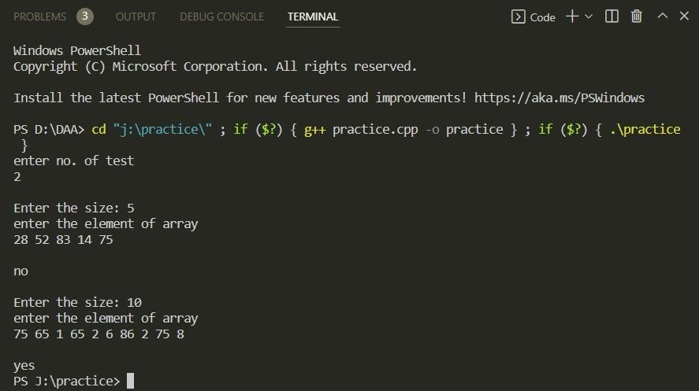

Program 10
10.Given an unsorted array of integers, design an algorithm and implement it using a program to sort an array of elements by dividing the array into two subarrays and combining these subarrays after sorting each one of them. Your program should also find number of comparisons and inversions during sorting the array. ( Merge sort)

Algorithm:
Step 1 − divide the list recursively into two halves until it can no more be divided.
MERGE_SORT(arr, beg, end) if beg < end
set mid = (beg + end)/2 MERGE_SORT(arr, beg, mid) MERGE_SORT(arr, mid + 1, end) MERGE (arr, beg, mid, end)
end of if
END MERGE_SORT
Step 2 − merge the smaller lists into new list in sorted order.while (i < n1 && j < n2)
if (LeftArray[i] <= RightArray[j]) then a[k] = LeftArray[i];
i++;
else then
a[k] = RightArray[j]; j++;
k++;
end of while Complexity Analysis: Time Complexity:
Worst Case: T(n) = θ(𝑛logn) Best Case: T(n)= Ω(nlogn) Average Case:T(n) = θ(𝑛logn)

Space Complexity:
Worst Case=Best Case = Average case = θ(n)

Source code :
/*
Name: Garvit Grover
Univ. Roll No: 2018338
Section : A
*/

#include <bits/stdc++.h> using namespace std;
int _mergeSort(int arr[], int temp[], int left, int right,int *c); int merge(int arr[], int temp[], int left, int mid,int right,int *c); int mergeSort(int arr[], int array_size,int *c)
{
int temp[array_size];
return _mergeSort(arr, temp, 0, array_size - 1,c);
}
int _mergeSort(int arr[], int temp[], int left, int right,int *c)
{
int mid, inv_count = 0; if (right > left) {

mid = (right + left) / 2;
inv_count += _mergeSort(arr, temp, left, mid,c); inv_count += _mergeSort(arr, temp, mid + 1, right,c); inv_count += merge(arr, temp, left, mid + 1, right,c);
}
return inv_count;
}
int merge(int arr[], int temp[], int left, int mid,int right,int *c)
{
int i, j, k;
int inv_count = 0;

i = left; j = mid;
k = left;
while ((i <= mid - 1) && (j <= right)) {
*c=*c+1;
if (arr[i] <= arr[j]) { temp[k++] = arr[i++];
}
else {
temp[k++] = arr[j++];

inv_count = inv_count + (mid - i);
}
}
while (i <= mid - 1) temp[k++] = arr[i++];

while (j <= right) temp[k++] = arr[j++];

for (i = left; i <= right; i++) arr[i] = temp[i];

return inv_count;
}
int main()
{
int t;
cout<<"enter no. of test"<<endl; cin>>t;
while(t!=0)
{
int n;
cout<<"\nenter the size of array"<<endl;

cin>>n; int arr[n]; int j;
int c=0;
cout<<"enter the element of array"<<endl; for(int i=0;i<n;i++)
{
cin>>arr[i];
}
int s = mergeSort(arr, n,&c); for(int i=0;i<n;i++) cout<<arr[i]<<" ";
cout<<"\ncomparision "<<c<<endl; cout << "inversions " <<s<<endl;
t--;
}
}

Output
/*
/*
Name: Garvit Grover
Univ. Roll No: 2018338
Section : A
*/

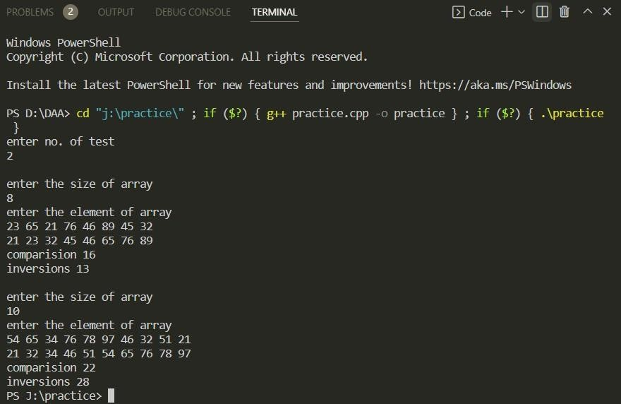

Program 11
11.Given an unsorted array of integers, design an algorithm and implement it using a program to sort an array of elements by partitioning the array into two subarrays based on a pivot element such that one of the sub array holds values smaller than the pivot element while another sub array holds values greater than the pivot element. Pivot element should be selected randomly from the array. Your program should also find number of comparisons and swaps required for sorting the array. ( Randomised QuickSort)

Algorithm:
QUICKSORT (array A, start, end)
{
1 if (start < end) 2 {
- p = partition(A, start, end)
- QUICKSORT (A, start, p - 1)
- QUICKSORT (A, p + 1, end)
6 }
}
PARTITION (array A, start, end)
{
1 pivot ? A[end] 2 i ? start-1
3 for j ? start to end -1 { 4 do if (A[j] < pivot) {
- then i ? i + 1
- swap A[i] with A[j] 7 }}
8 swap A[i+1] with A[end] 9 return i+1
}

Complexity Analysis: Time Complexity:
Worst Case: T(n) = θ(𝑛^2) Best Case: T(n)= Ω(nlogn) Average Case:T(n) = θ(𝑛logn)

Space Complexity:
Worst Case=Best Case = Average case = θ(nlogn)
Source code :
/*
Name: Garvit Grover
Univ. Roll No: 2018338
Section : A
*/

#include<iostream> #include<algorithm> using namespace std;
int partition(int *arr,int l,int r,int *c,int *s)
{
int piovt=arr[r]; int i=l-1;
for(int j=l;j<=r-1;j++)
{
(*c)++;
if(arr[j]<=piovt)
{
i++;
swap(arr[i],arr[j]); (*s)++;
}
}
swap(arr[i+1],arr[r]); (*s)++;
return (i+1);
}
void quicksort(int *arr,int l,int r,int *c,int *s)
{
if(l<r)
{
int p=partition(arr,l,r,c,s); quicksort(arr,l,p-1,c,s); quicksort(arr,p+1,r,c,s);
}

}
int main()
{
int t;
cout<<"enter no. of test"<<endl; cin>>t;
while(t!=0)
{
int n;
cout<<"\nenter the size of array"<<endl; cin>>n;
int arr[n];
int s=0,c=0;
cout<<"enter the element of array"<<endl; for(int i=0;i<n;i++)
{
cin>>arr[i];
}
quicksort(arr,0,n-1,&c,&s);
for(int i=0;i<n;i++)
{
cout<<arr[i]<<" ";
}
cout<<"\ncomparision "<<c<<endl; cout<<"swaps "<<s<<endl;
t--;
} }

Output
/*
Name: Garvit Grover
Univ. Roll No: 2018338
Section : A
*/
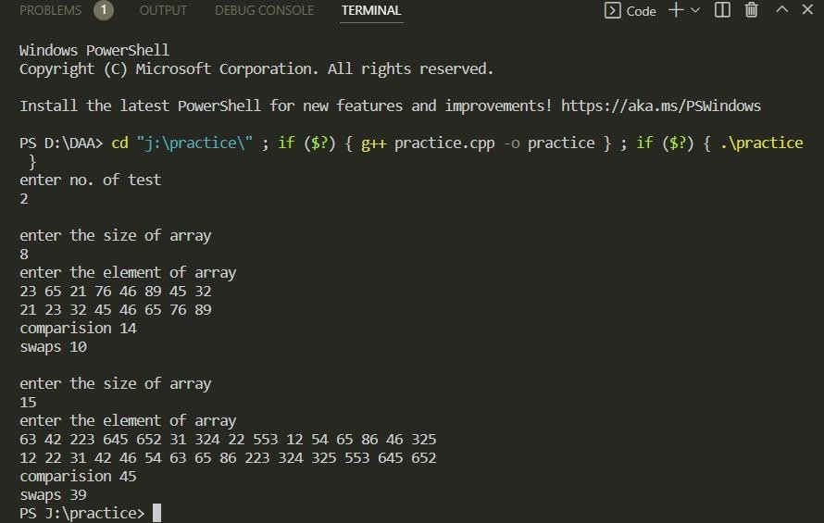

Program 12
12.Given an unsorted array of integers, design an algorithm and implement it using a program to find Kth smallest or largest element in the array. (Worst case Time Complexity = O(n))

Algorithm:
function quickSelect(list, left, right, k) if left = right
return list[left]
Select a pivotIndex between left and right pivotIndex := partition(list, left, right,pivotIndex) if k = pivotIndex
return list[k]
else if k < pivotIndex right := pivotIndex - 1
else
left := pivotIndex + 1

Complexity Analysis:
Time Complexity:
Worst Case: T(n) = θ(𝑛logn) Best Case: T(n)= Ω(n) Average Case:T(n) = θ(𝑛^2) Space Complexity:
Worst Case= θ(n)
Best Case = Average case = θ(logn)
Source code:

/*
Name: Garvit Grover
Univ. Roll No: 2018338
Section : A
*/

#include<iostream> #include<algorithm> using namespace std;
int partition(int *arr,int l,int r)
{
int pivot=arr[r]; int i=l-1;

for(int j=l;j<=r-1;j++)
{
if(arr[j]<pivot)
{
i++;
swap(arr[j],arr[i]);

}
}
swap(arr[i+1],arr[r]); return i+1;
}
int quickselect(int *arr,int l,int r,int k)
{
if(k>0&&k<=r-l+1)
{
int p=partition(arr,l,r); if(p-l==k-1)
return arr[p]; if(p-l>k-1)
return quickselect(arr,l,p-1,k);

return quickselect(arr,p+1,r,k-p+l-1);
}
return INT_MAX;
}
int main()
{
int t;
cout<<"enter no. of test"<<endl; cin>>t;
while(t!=0)
{
int n;
cout<<"enter the size of array"<<endl; cin>>n;
int arr[n]; int j;
for(int i=0;i<n;i++)
{
cin>>arr[i];
}
int k;
cout<<"enter key"<<endl; cin>>k;
int s=quickselect(arr,0,n-1,k); cout<<s<<endl;
t--;
}
}

Output
/*
Name: Garvit Grover
Univ. Roll No: 2018338
Section : A
*/

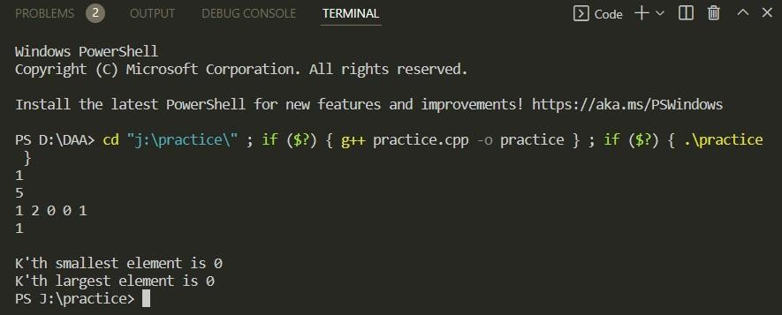

Program 13
13.Given an unsorted array of alphabets containing duplicate elements. Design an algorithm and implement it using a program to find which alphabet has maximum number of occurrences and print it. (Time Complexity = O(n)) (Hint: Use counting sort)

Algorithm:
countingSort(array, n)
max = find maximum element in the given array create count array with size maximum + 1 Initialize count array with all 0's
for i = 0 to n
find the count of every unique element and store that count at ith position in the count array for j = 1 to max
Now, find the cumulative sum and store it in count array for i = n to 1
Restore the array elements
Decrease the count of every restored element by 1 end countingSort

Complexity Analysis:
Time Complexity:
Worst Case: T(n) = θ(𝑛+k) Best Case: T(n)= Ω(n+k) Average Case:T(n) = θ(𝑛+k) Space Complexity:
Worst Case=Best Case = Average case = θ(k)
Source code :

/*
Name: Garvit Grover
Univ. Roll No: 2018338
Section : A
*/

#include<bits/stdc++.h> using namespace std; int main()
{
int t;
cout<<"enter no. of test"<<endl;

cin>>t; while(t!=0)
{
int n;
cout<<"enter the size of array"<<endl; cin>>n;
char arr[n];
for(int i=0;i<n;i++) cin>>arr[i];
int count[26]; memset(count,0,sizeof(count)); for(int i=0;i<n;++i)
{
int k=arr[i];
++count[k-97];
}
int l=count[0],j=0; for(int i=1;i<26;i++)
{
if(l<count[i])
{
l=count[i]; j=i;
}
}
if(l>1)
{
char a='a'+j; cout<<a<<"-"<<l;
}
else
{

cout<<"no duplicate found"<<endl;
}
t--;
}
}

Output
/*
Name: Garvit Grover
Univ. Roll No: 2018338
Section : A
*/
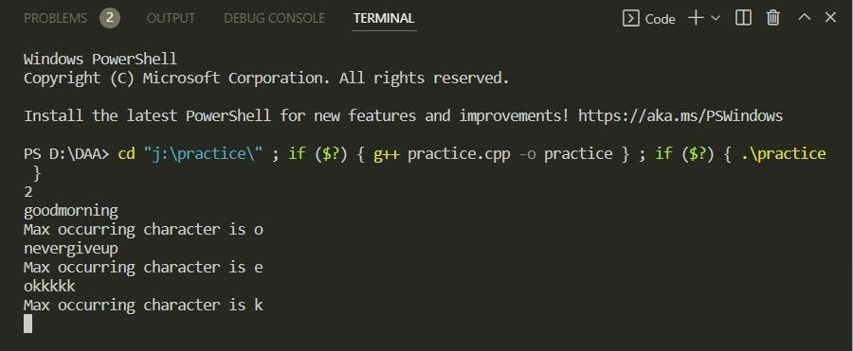

Program 14
14.Given an unsorted array of integers, design an algorithm and implement it using a program to find whether two elements exist such that their sum is equal to the given key element. (Time Complexity = O(n log n))

Algorithm:
Step 1 − divide the list recursively into two halves until it can no more be divided.
MERGE_SORT(arr, beg, end) if beg < end
set mid = (beg + end)/2 MERGE_SORT(arr, beg, mid) MERGE_SORT(arr, mid + 1, end) MERGE (arr, beg, mid, end)
end of if
END MERGE_SORT
Step 2 − merge the smaller lists into new list in sorted order.while (i < n1 && j < n2)
if (LeftArray[i] <= RightArray[j]) then a[k] = LeftArray[i];
i++;
else then
a[k] = RightArray[j]; j++;
k++;
end of while

Complexity Analysis:
Time Complexity:
Worst Case: T(n) = θ(𝑛logn) Best Case: T(n)= Ω(nlogn) Average Case:T(n) = θ(𝑛logn) Space Complexity:
Worst Case=Best Case = Average case = θ(n)

Source Code :

/*
Name: Garvit Grover
Univ. Roll No: 2018338
Section : A
*/

#include <iostream> #include <algorithm> using namespace std;
void merge(int *arr,int l,int e,int mid)
{
int i=0,j=0,k=l; int n1=mid-l+1; int n2=e-mid; int L[n1];
int R[n2];
for(int i=0;i<n1;i++)
{
L[i]=arr[l+i];
}
for(int i=0;i<n2;i++)
{
R[i]=arr[mid+1+i];
}
while(i<n1&&j<n2)
{
if(L[i]<=R[j])
{
arr[k]=L[i]; i++;
}
else
{
arr[k]=R[j]; j++;
}
k++;

}
while(i<n1)
{
arr[k]=L[i]; i++;
k++;
}
while(j<n2)
{
arr[k]=R[j]; j++;
k++;
}
}
void mergesort(int *arr,int l,int e)
{
if(l<e)
{
int mid=l+(e-l)/2; mergesort(arr,l,mid); mergesort(arr,mid+1,e); merge(arr,l,e,mid);
}
}
int main()
{
int t;
cout<<"enter no. of test"<<endl; cin>>t;
while(t!=0)
{
int n;

cout<<"enter the size of array"<<endl; cin>>n;
int arr[n]; int j;
cout<<"enter the element of array"<<endl; for(int i=0;i<n;i++){
cin>>arr[i];}
int key;
cout<<"enter key"<<endl; cin>>key; mergesort(arr,0,n-1);
int l=0,r=n-1,f=0; while(l<r)
{
if(arr[l]+arr[r]==key)
{
cout<<arr[l]<<" "<<arr[r]<<endl; f=1;
l++,r--;
}
else if(arr[l]+arr[r]<key) l++;
else r--;
}
if(f==0)
cout<<"no such pairs"<<endl; t--;
}}

Output
/*
Name: Garvit Grover
Univ. Roll No: 2018338
Section : A
*/

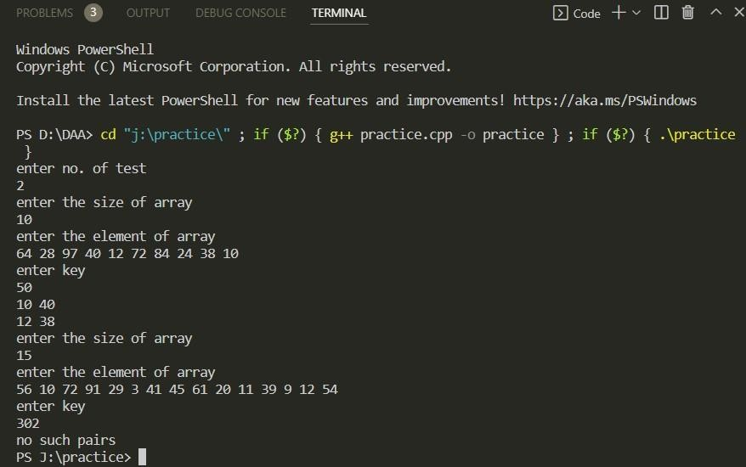

Program 15
15.You have been given two sorted integer arrays of size m and n. Design an algorithm and implement it using a program to find list of elements which are common to both. (Time Complexity = O(m+n))

Algorithm:
Function intersection(arr1,arr2,m,n) Step 1 set i=0,j=0
Step 2 while(i<m&&j<n)
{
if(arr1[i]==arr2[j]&&(arr1[i-1]!=arr1[i]||arr2[j-1]!=arr2[j])) then
{
cout<<arr1[i]<<" "; i++;
j++;
}
else if(arr1[i]>arr2[j]) j++;
else i++;
}
Step 3 exit

Complexity Analysis:
Time Complexity:
Worst Case: T(n) = θ(𝑛) [ Linear] Best Case: T(n)= Ω(1) [ Constant] Average Case:T(n) = θ(𝑛) [ Linear] Space Complexity:
Worst Case=Best Case = Average case = θ(1) [ Constant ]
Source code :

/*
Name: Garvit Grover
Univ. Roll No: 2018338
Section : A
*/

#include<iostream> using namespace std; int main()
{
int t;
cout<<"enter no. of test"<<endl; cin>>t;
while(t!=0)
{
int m;
cout<<"enter the size of array"<<endl; cin>>m;
int arr1[m];
cout<<"enter the element of array"<<endl; for(int i=0;i<m;i++)
{
cin>>arr1[i];
}
int n;
cout<<"enter the size of array"<<endl; cin>>n;
int arr2[n];
cout<<"enter the element of array"<<endl; for(int i=0;i<n;i++)
{
cin>>arr2[i];
}
int i=0,j=0; while(i<m&&j<n)
{
if(arr1[i]==arr2[j])
{
cout<<arr1[i]<<" "; i++;
j++;

}
else if(arr1[i]>arr2[j]) j++;
else i++;
}
t--;
}
}

Output
/*
Name: Garvit Grover
Univ. Roll No: 2018338
Section : A

